**Core imagens of different lithologic groups**

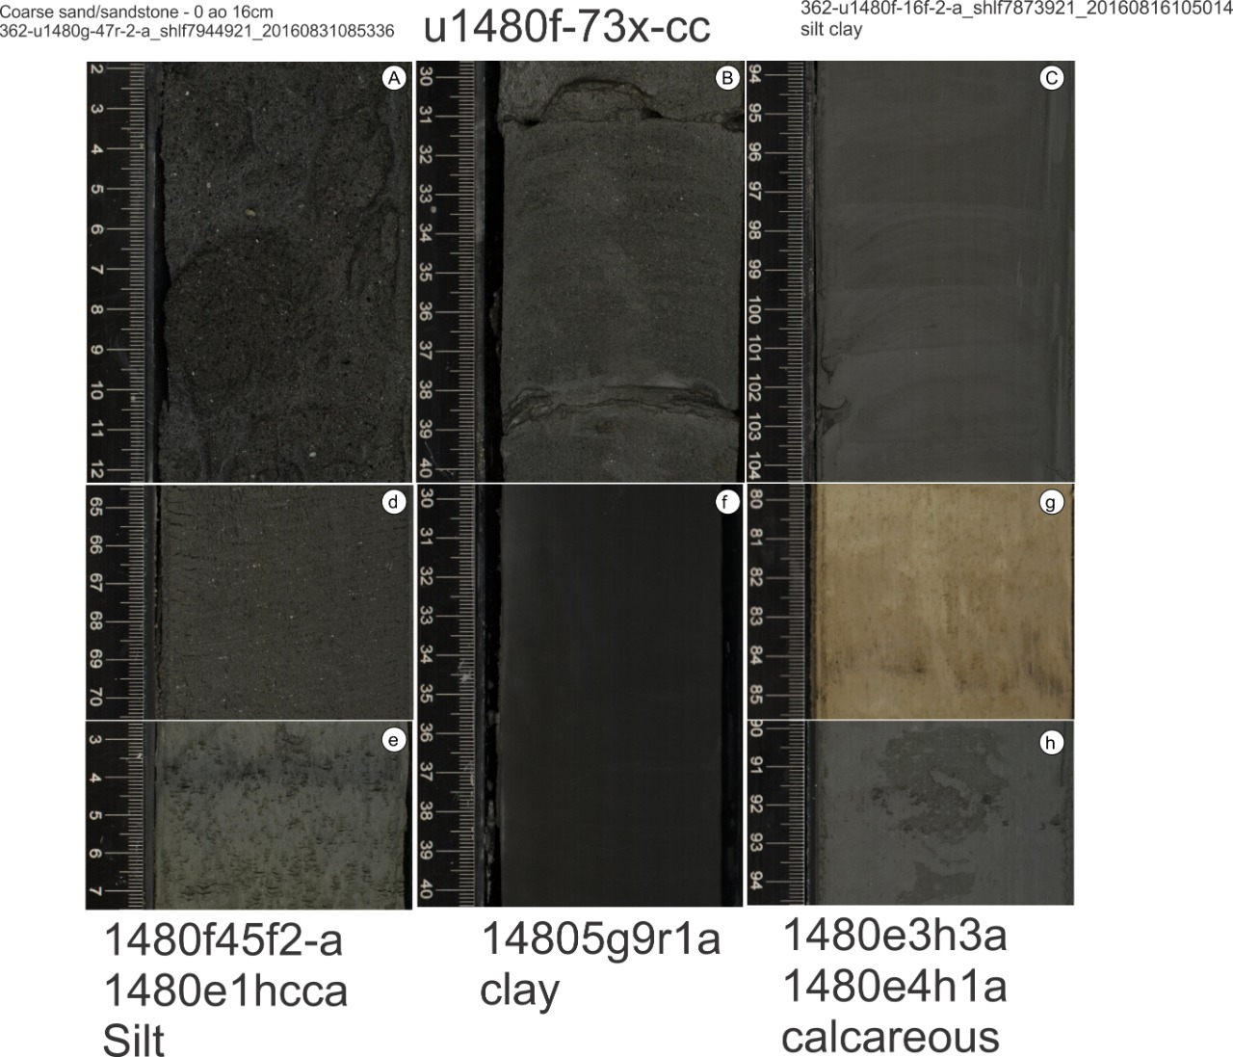

Figure 1 The core imagens of different lithologic groups. **A** represent the image of group GP, G1, G2 and G3, Litho1 - Coarse sand/sandstone. **B** represent the image of group GP, G1, G2 and G3, Litho2 - Alternating sand/sandstone and mud/mudstone layers. **C** represent the image of group GP – Litho5 - Silty clay/claystone, G2 – Litho3 - Silty clay/claystone and G3 – Litho3 - Silty clay/claystone. **d** and **e** represent the image of group GP – Litho5 - Silt/Siltstone, G1 – Litho2 - Silt/Siltstone, G2 – Litho3 - Silt/Siltstone and G3 - Litho4 - Silt/Siltstone. **f** represents the image of group GP – Litho5 - Clay/claystone, G1 – Litho2 - Clay/claystone, G2 – Litho3 - Clay/claystone and G3 – Litho5 - Clay/claystone. **g** and **h** represent the image of group GP – Litho6 - Calcareous clay/claystone, G1 – Litho3 - Calcareous clay/claystone, G2 – Litho4 - Calcareous clay/claystone and G3 – Litho6 - Calcareous clay/claystone.